Purpose of webinar / resiliency

Were all going through challenges, and our brains are not designed to help us automatically. Our brains need help. Optimism, resiliency, is all about the internal game. Most specifically about our ability and willingness to make conscious, positive choices on an ongoing basis. Many of us have a good track record with this, but suddenly, the situations of change that the pandemic is creating, we have no pattern for in the brain. There isn’t any thing for the brain to fall back on and feel safe.

The idea behind the model is that by becoming consciously aware of what is happening in the brain, we are empowered to make more mindful, intentional choices, and foster brain health (i.e mental health).

3 part brain
- Located in the limbic system
- Is in charge of looking out for danger
- REACTS to both physical & social threats and rewards

SOCIAL THREATS: Idea
The limbic region or system will take control in the middles of a physical threeat. We might be crossing the street, and suddenly a car turns into the cross walk and we step back automatically - quicker than we were even conscious of the decison. The brain can react the same way to social threats. inly We all have social threats , but some might be more triggers for someone than someone else.
During this time of uncertainty and change, you might be reacting more strongly than in in more predictable times because of these social threats. Share what they are and then come back to control and reshow the model. Talk about internal control and external control. Both are important. External we can change something in our environment to make things easier / better / - simple example - flexible work schedules have been shown to increase morale and productivity because of the choices to manage their own schedules more in
The brain likes predictability and certainty. Why? Good question to answer in preparing for webinar. The idea of having some control over what is going to happen which is why this pandemic is so incredibly difficult. People with internal control = ability to choose perspectives, actions and intentions will have more resiliency.
Physical pain same as social. Pain
Study: re-listeen

RESPECT
Brain likes to feel that people are treating us well - not going to be put down
Amongst our peers - look stupid brain doesn’t like th side a being disrespected

EQUITY
Getting our fair share. If our brains feel like things aren’t equitable, like we’re not getting what we deserve, we’ll go into that limbic system - into that emotional brain
We all want to get our fair share, but we recognize that fair is not equal. Even children understand that not everyone needs things in the same way. A special needs child has an extra guide in the room, another child might like that, but recognizes they have what they need anyway - so it’s fair - equitable.

ALLIANCES
The people whom we have alliances with are very important to us - to our brains.
The social brain - if these feel threatened will go into a lower limbic response

CONTROL
The brain likes predictability and certainty. Why? Good question to answer in preparing for webinar. The idea of having some control over what is going to happen which is why this pandemic is so incredibly difficult. People with internal control = ability to choose perspectives, actions and intentions will have more resiliency.Control is the idea that we have some ways to exert a sense of control - this can be an inside or outside sense. Internal control in times of change is crucial to resiliency. Things are not in our control suddenly: kids home, sharing a cramped work space with a family member, new routines, reduced physical and emotional contact

Overwhelm - everything coming at us and we feel like we don’t have way to exert some control & there is a feeling of low support

TERRITORY
Is if we have sort of territorial feeling over our personal attachments - both healthy and unhealthy. We like to feel safe from unexpected change or unpredictability.

SIMILARITY
This is the degree to which we see as being similar to us or we relate to with ease. Many of these stem from our days in tribes. - Someone is familiar to us they are less likely to be seen as a threat by the brain. We can tell ourselves we are comfortable with a difference - but in real time the brain has it’s own reaction.

Studies show it can be even a small amount of similarity. David Desteno did a study where he had people tap at the same time or at different times and the people who tapped at the same time put significantly less hot sauce the other person was going to drink. Negotiating a Deal. Had them either eat the same snack both sides chips or brownies. Other time - each side ate a different snack, it took sig longer to reach the deal. See someone as different - even in a small way - we are less likely to be positive emotionally or feel protective so its important to recognize this so we can find these points of similarity to calm our brain down - oh yeah - wee have something in common.
Eat different

REWARD SYSTEM
You need to find those things that make you think, wow, that felt good. Keeping the positive brain online.

A large body of research has shown that optimism and positive emotions have a robust association with positive physical and mental health. Nearly all of the resilient people we interviewed were optimists, but not “rose-colored” optimists. Instead, they were realistic optimists who paid close attention to both positive and relevant negative information but rapidly filtered out or disengaged from irrelevant negative information. Realistic optimists use relevant negative stimuli to inform their decisions, but they do not dwell on it.
The neuroscience of optimism is complex and only partially understood. Research by Richard Davidson and others has shown that low activity in the left prefrontal cortex is associated with symptoms of depression, compromised ability to sustain positive emotions and activation of the nucleus accumbens reward system, and slow recovery from laboratory-induced negative emotion and amygdala activation. On the other hand, high activity in the left prefrontal cortex is associated with positive emotion, increased ability to sustain positive emotions and nucleus accumbens activation, and more rapid reduction of laboratory-induced negative emotion and amygdala activation.

Perception is not static

When perception narrows, it doesn’t naturally occur to us to challenge our thinking and turn the tables to look at a situation from another person’s perspective – even though that’s exactly what we need to do.

Higher BrainState is critical to keep perception open and to be willing to see things differently

Resilience
Experiencing life from a place of possibility opens us up to opportunities where we can grow, learn, and continue to contribute. It can reshape our purpose and be used to have a positive impact in the lives of others.

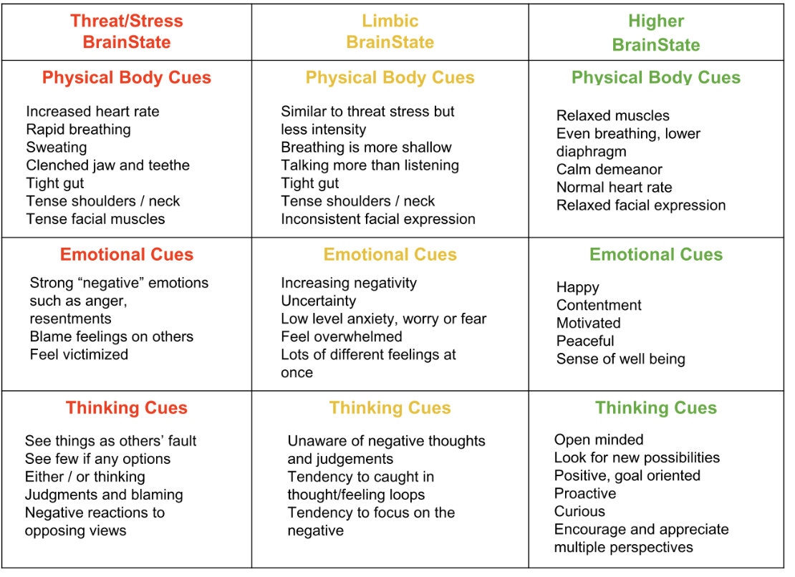

BrainStates Awareness - Cues Chart

